22 July 2019
ELC EMSENI - ST JOHANNIS
Our Dearest Friends

It had been a while ago since we last share on what is happening in our homes. That is the reason why when we grab this little opportunity we thought a lot about you and we decided to send you this small brief.

We had one of the coldest and a very dry winter this year. Thanks God, the Spring is approaching slowly. We can’t predict at the moment whether God will give us rain this coming Summer, but we always hope for the best as he is the only God who is in control, because we really are facing a difficult situation when comes to water shortage in the whole area of Rorke’s Drift. 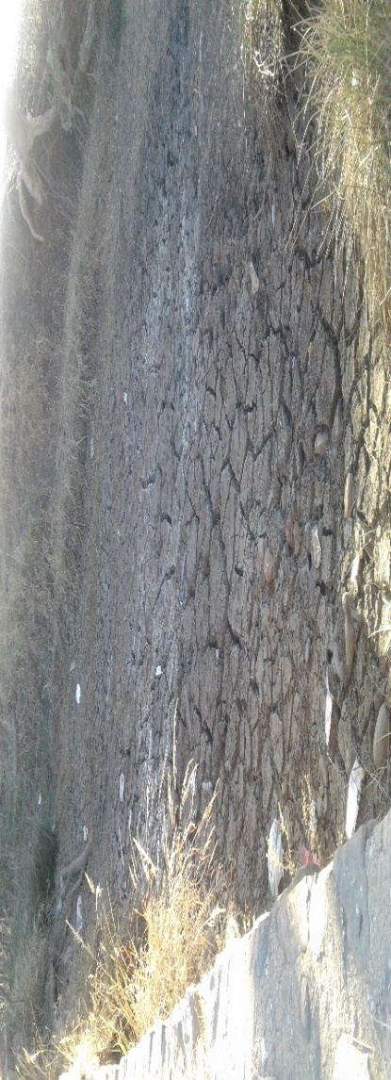
This is a picture of a small stream under the bridge we drive across every day from Emseni to Church, or Clinic, or to the main road to Dundee town. It is the first time we find it in this condition since we started working at Emseni 26 years ago.

Towards the end of the Year 2017, we applied for funding from Lottery. Fortunately we were lucky to be considered after we patiently waited for almost a year for their response. In December last year, they paid the money into our account, but they did not fund everything we requested for. They only gave us funding for the following:

- The New Bakkie – long wheel based (2x4) Cost: R308 000.00
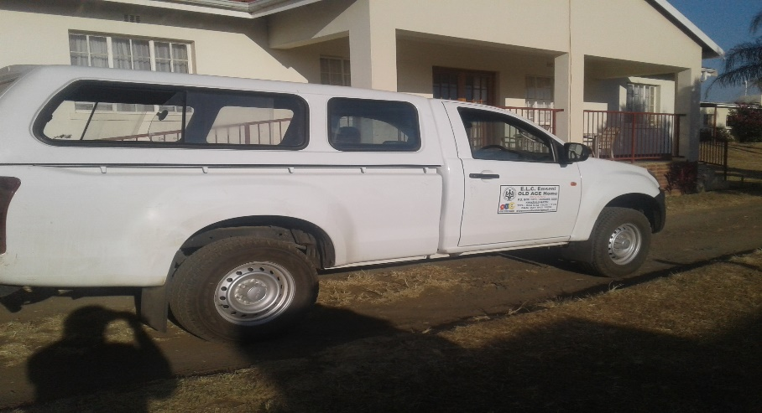
- Renovation of the old kitchen: Cost: R400 000.00
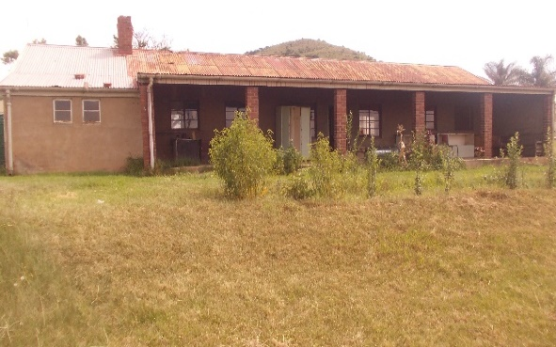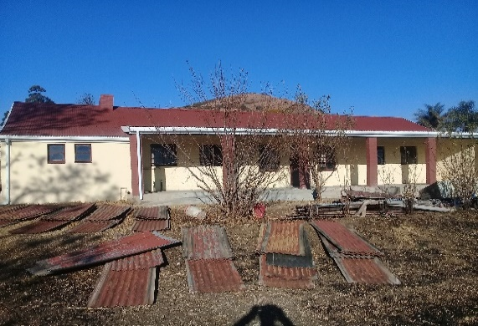
From this condition to this condition
- Employment of two Enrolled Nurses ( One year contract: May 2019 to April 2020).

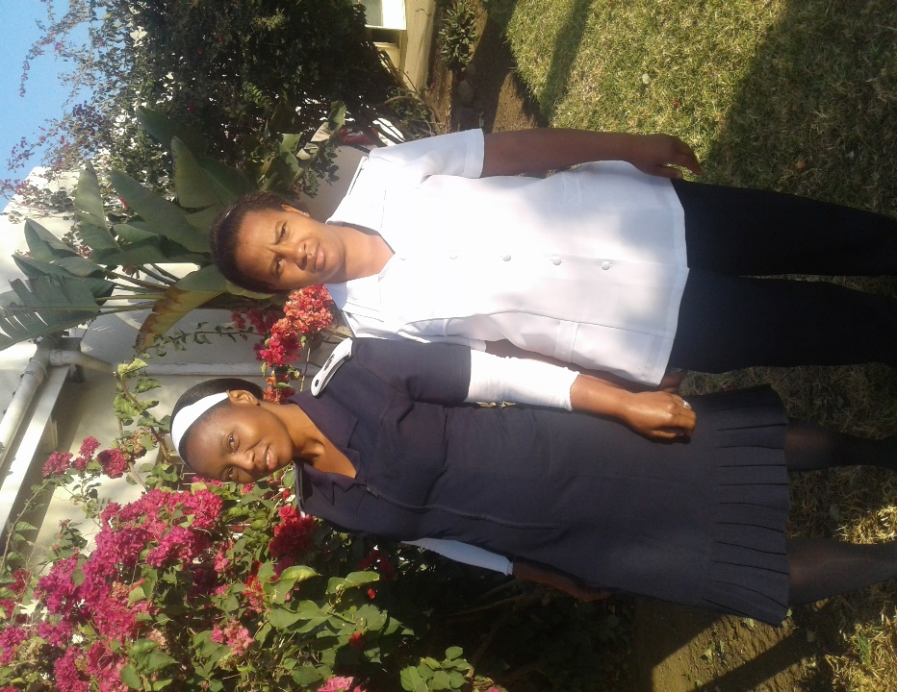

The rest of money was for putting National Lottery logos in every thing sponsored by them, the logo on the doors of the car, and we are still going to put one on the wall of the renovated kitchen, not to nurses of course, ha-ha! They also paid out the accounting fee for their money and also bank charges for their money only.
The other very important thing we applied for, but they did not consider to be funded, was the residents beds. They are all warn out and old. They are no more comfortable and healthy for our residents to sleep on. Unfortunately, we have to wait the whole one year before we are welcome to apply again. They call it a ‘Cooling off period.” We will try to apply again next year. The beds are too expensive for us to buy for 60 residents. Each standard single bed cost more than R3,000.00.
We are trying to find out if we can get a place like a wholesaler or a warehouse, which specializes with equipments for facilities like these and try to make quotations from them, but there is no chance that we can be able to buy them, we can only wait until we get sponsors or fundraise for that.
Well, that is all we can share with you at the moment. We also hope to hear from you dear friends
With love and warm regards from

MARYGOLD and JABU
FOR ALL OF US AT EMSENI HOME

